React JS – PL3- Shopping Pets

Case Study

Contents

1. Project Information 3

2. Project Description 3

3. Flow Diagram: 5

4. Environment Setup 5

5. Project Structure 7

6. Requirements 9

6.1 Creating a New Registration Page 9

6.2 Creating a login page 12

6.3 Creating the Dogs page: 15

6.4 Creating the Birds page: 17

6.5 Creating the orders page: 19

6.6 Create Reusable Components 21

6.7 Implement Redux: 22

6.8 Implement Webpack 23

7. Instructions to zip the completed code 24

# Project Information

|  |  |
| --- | --- |
| **Skill** | React |
| **Proficiency** | Level 3 |
| **Duration** | 12 Hours |
| **Version** | 1 |

# Project Description

Once upon a time in the bustling town of Petville, there was a community of passionate pet enthusiasts who dreamt of a seamless and delightful online experience for finding and purchasing their furry and feathery companions. Their wish was soon realized with the inception of the "Shopping Pets" project, an innovative online platform designed to revolutionize the way people interacted with pet shopping.

The Shopping Pets platform aimed to offer a wide range of features to enhance the pet purchasing journey. It all began with a simple registration process. Users were welcomed with a clean and inviting registration page, where they could create their accounts and embark on their pet-loving adventure. The page gracefully captured their personal information, including their first and last names, email addresses, and passwords. Through careful validation, each detail was meticulously verified to ensure accuracy and completeness.

As users joyfully submitted their registration forms, the system sprang into action. Behind the scenes, the project stored their information securely in a JSON file, creating user accounts that would grant access to an array of pet-shopping delights. The newly registered users were then seamlessly redirected to the login page, ready to embark on their shopping spree.

The login page was designed with elegance and security in mind. Two input fields, Username and Password, awaited the users' credentials. Upon entering their information, the system worked diligently to verify the validity of their login details. If the credentials were found to be correct, the users were greeted with a warm welcome and swiftly transported to the captivating world of pet listings.

The project showcased separate pages for dogs and birds, each with its own unique charm. Users were greeted by a visually enticing display of pets, complete with vivid images, prices, and quantities. A simple yet powerful quantity field allowed users to choose the desired number of pets they wished to bring home. The shop now button beckoned them to fulfill their furry dreams.

As users reveled in the joy of choosing their new companions, the project maintained an orders page to capture their purchase history. Each order was thoughtfully documented, featuring the pet's image, price, quantity, total cost, and purchase date. This personalized history served as a cherished memory of their pet-shopping journey, bringing smiles to their faces with every glance.

Throughout this incredible project, care was taken to ensure the utmost convenience and security for the users. User authentication mechanisms ensured that only registered users could access certain pages and perform actions like making purchases. Validation checks diligently safeguarded the accuracy and completeness of user information, preventing any mishaps along the way. And with the power of Redux, the state management was flawlessly orchestrated, creating a seamless experience for both the users and the system.

The Shopping Pets project brought the magic of pet shopping to life, offering a user-friendly and secure platform for pet enthusiasts to find and purchase their beloved companions. The careful design of reusable components added modularity, scalability, and maintainability to the codebase. Webpack optimized the project's performance, reducing bundle sizes and improving loading times.

As the curtain falls on our story, the Shopping Pets project continues to bring joy to the pet-loving community of Petville. With each new account created, each pet listed, and each order placed, the project thrives, weaving a tapestry of love, companionship, and delightful shopping experiences for pet enthusiasts far and wide.

**Key Features:**

User Authentication: The project includes user authentication functionality, allowing users to create accounts, log in, and log out. This ensures that only registered users can access certain pages and perform actions such as making purchases.

User Registration: New users can register by providing their personal information, including their first name, last name, email address, and password. Upon successful registration, users can log in using their credentials.

Product Listing: The project features separate pages for listing dogs and birds. Each pet listing contains essential details such as an image, price, and quantity.

Orders: After selecting their desired pets, users can place orders for the selected items. The project maintains an orders page that displays users' order history, including details such as purchased pets, total cost, purchase quantity, and purchase date.

# Flow Diagram:

In order to purchase pets, users must be registered on the platform.

New users can create an account by providing their personal information and registering on the platform.

Access the application by logging in with a valid Email ID and Password.

Upon successful login, users will be redirected to the Dogs page, where they can proceed to purchase their desired dogs.

On the birds page, users can explore a list of birds along with their corresponding details, including price, bird image, quantity, and a convenient "Shop Now" button.

On the order page, users can view the details of their ordered pets, including pet image, price, quantity, total amount, and the date of purchase.

# Environment Setup

**Software Required**

* Node.js version 16 or later
* React v18
* Visual Studio Code editor version 1.76.x or later
* Chrome or Edge browser (latest version)

**Getting the Template Source Code**

* The coding should be done based on a template source code provided for this case study.
* This will help to quickly get started with case study, as some features of coding will be already implemented.
* Find below the code template embedded:



* Once the source code is available, open the root folder ‘shopping_pets’ in Visual Studio Code.

**JSON Server Setup**

* Using JSON Server, we can quickly start and REST API service in our desktop.
* JSON Server is a npm package.
* Run ‘npm install -g json-server@0.17.1’ in terminal to install JSON Server.
* In the root folder of the provided source code, there is a file named ‘db.json’ in the root folder.
* Open this file in Visual Studio Code to check its content, it contains a sample set of user details and feedbacks.
* This JSON file (db.json) must be used as database for JSON Server.
* Open a new terminal window in Visual Studio Code and start the JSON Server by running the below command in a terminal window:

json-server db.json –-port 3002

This command will start the backend service.

* After starting the server, we can see the available endpoints displayed in the terminal.
* Try the following URLs in the browser, which assures that backend is running:

<http://localhost:3002/users>

http://localhost:3002/orders

* If JSON data is displayed in the browser, it means that the backend service is successfully started.
* The first endpoint provides all the users already registered; the second endpoint provides all the ordered pet details.
* Make note that it is possible to perform GET, POST operations in these endpoints.
* The JSON Server should be running when Shopping pets React application runs.
* Whenever working on the React application first start the JSON server using the above command.
* After completion of development in React application, the JSON server can be stopped in the terminal using Ctrl+C shortcut key.
* More details about JSON Server can be found at <https://www.npmjs.com/package/json-server>.

**React app setup**

* Open a new terminal window in Visual Studio Code and run npm install command to get the dependencies for the React project.
* Run the React application by entering commend **npm start**
* The React application will be launched it in the browser using link http://localhost:3000/
* It should display the below screen layout.

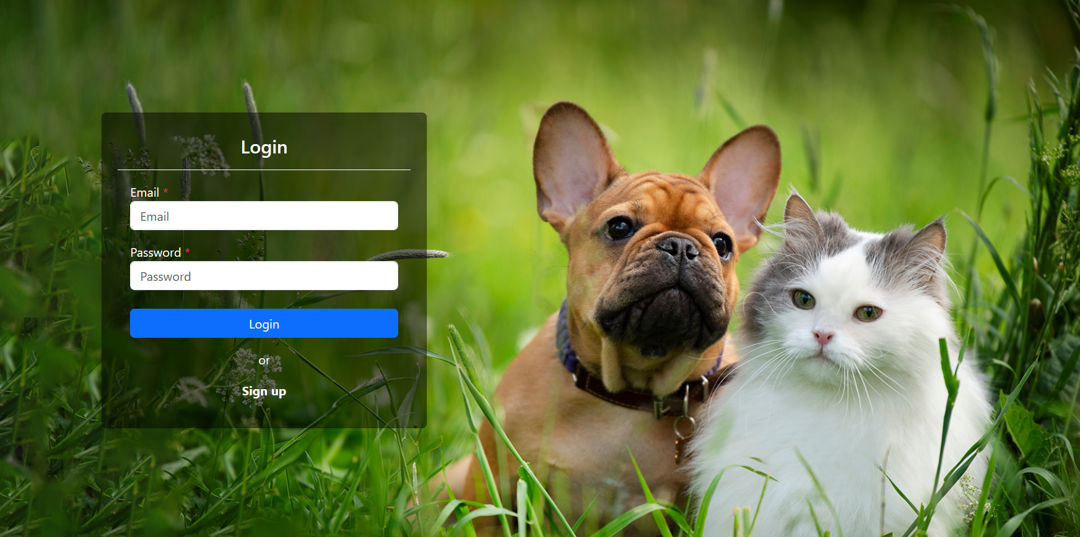

* You have successfully completed the application setup.
* To design the UI, the Bootstrap React UI component library was included
* The React app can provide a Progressive Web Apps (PWA) implementation, which is useful for enabling this app on desktop or mobile.

# Project Structure

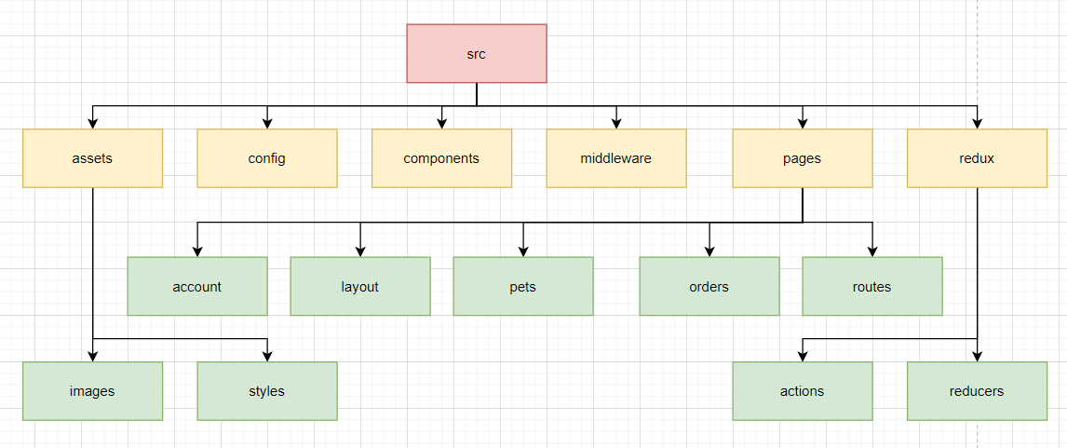

* In this code structure, the main code files are located under src folder
* In src/assets in this folder used to maintain the images and css styles
* In src/config folder contains the language tools
* In src/component folder is used to maintain the hoc modules (Higher order component
* In src/middleware folder is contains the api
* In src/pages container layout available to the whole project.
* In src/redux to handling the login state management.
* In src/pages/layout folder is contains layout available to the header
* In src/routes folder is contains the routes of app

# Requirements

## 6.1 Creating a New Registration Page

|  |  |
| --- | --- |
| Problem Statement | The goal is to design a clean and user-friendly registration page that allows customers to create a new account for purchasing pets. The page should include form fields to capture essential customer information, such as first name, last name, email address, and password. Additionally, a section should be provided for customers to create a user account.  To ensure data accuracy and completeness, user information and details must be validated. If any errors are detected, appropriate error messages should be displayed at the top of the page using toast notifications.  Upon successful submission of the registration form, the user's information should be stored in a JSON file, and a user account should be created. Once registered, users can proceed to the login page to access their account and make pet purchases |
| Design Consideration | When designing the registration form fields, please refer to the provided screen shots. It is recommended to use the images available in the assets/image folder. Consider the following design considerations:   * Utilize a form with a background image, positioned on the left side with a transparent black color scheme. * Use the default primary color for buttons. * Align input fields in the center with single rows. * Implement form validation using Formik. * Display alert messages using toast notifications. |
| Business Rules and Process | To access the registration page, users can click on the "Signup" option, which will navigate them to the registration page.  If the registration form is submitted without completing any required fields, appropriate error messages will be displayed, as shown in the attached screenshot.  Upon successfully filling and submitting all fields, a new account will be created.  After registration, users will be redirected to the login page, where they can log in using their valid username and password.  Clicking on "Login" in the right corner of the navigation section will navigate users to the login page.  If users do not have an account, they can click on the "Signup" option to navigate to the registration page.  API Endpoint: http://localhost:3002/users |
| Skills and Features (Technical competencies validated) | * Implement the components which fits the component library standards. |
| Time Required | 1 Hour |
| Impacted components | Here is the list of components that need to be either modified or developed to meet the project requirements.  Project folder structure:   * src/pages/account/Register.tsx |

**Expected User Interface**

|  |
| --- |
|  |
| **User Interface with error message:** |

## 6.2 Creating a login page

|  |  |
| --- | --- |
| Problem Statement | Designing and implementing a new login page that provides users with secure access to their accounts is a critical requirement for this web application. The login page should be designed with a strong emphasis on secure authentication processes for the users.  The login page consists of two input fields: Username and Password. After entering their credentials, if the provided username and password are valid, users should be redirected to the dogs page. However, if the login credentials are invalid, an error message stating "Invalid username or password" should be displayed using toast notifications. In such cases, users should be redirected back to the login page to retry their login attempt.  To ensure efficient login state management, the project utilizes Redux to store and manage the login state. |
| Design Consideration | When designing the login form fields, please refer to the provided screen shots. It is recommended to use the images available in the assets/image folder. Consider the following design considerations:   * Utilize a form with a background image, positioned on the left side with a transparent black color scheme. * Use the default primary color for buttons. * Align input fields in the center with single rows. * Implement form validation using Formik. * Display alert messages using toast notifications. |
| Business Rules and Process | If the login form is submitted with an invalid username or password, the error message should be displayed as shown in the attached screenshot.  If the login form is submitted with valid credentials, users will be navigated to the dogs page.  The login page should securely handle user authentication processes, ensuring the utmost security for user accounts.  API URL: <http://localhost:3002/users> |
| Skills and Features (Technical competencies validated) | * Implement the components which fits the component library standards. * Apply all the core and advance concepts in react and redux with all the necessary standards |
| Time Required | 2 Hours |
| Impacted components | Here is the list of components that need to be either modified or developed to meet the project requirements.  Project folder structure:   1. src/pages/redux/actions/Authactions.ts 2. src/pages/redux/reducers/authReducer.tsx 3. src/pages/account/Login.tsx |

**Expected User Interface:**

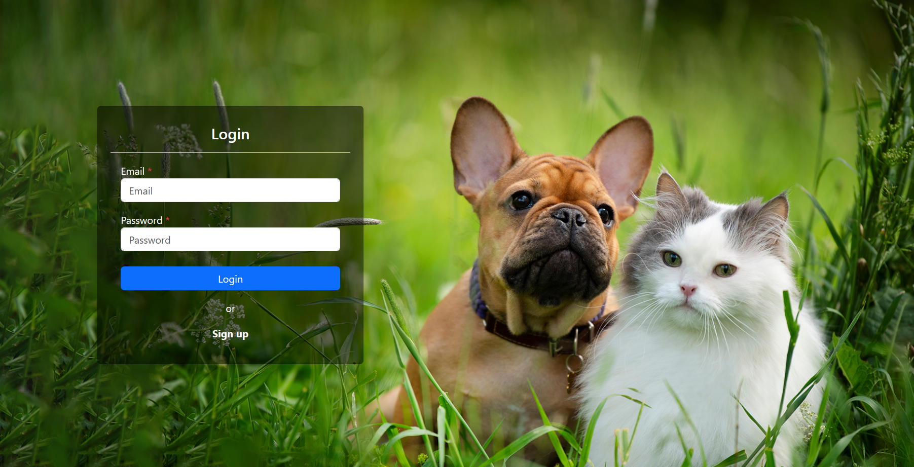

**Expected User Interface with error message:**

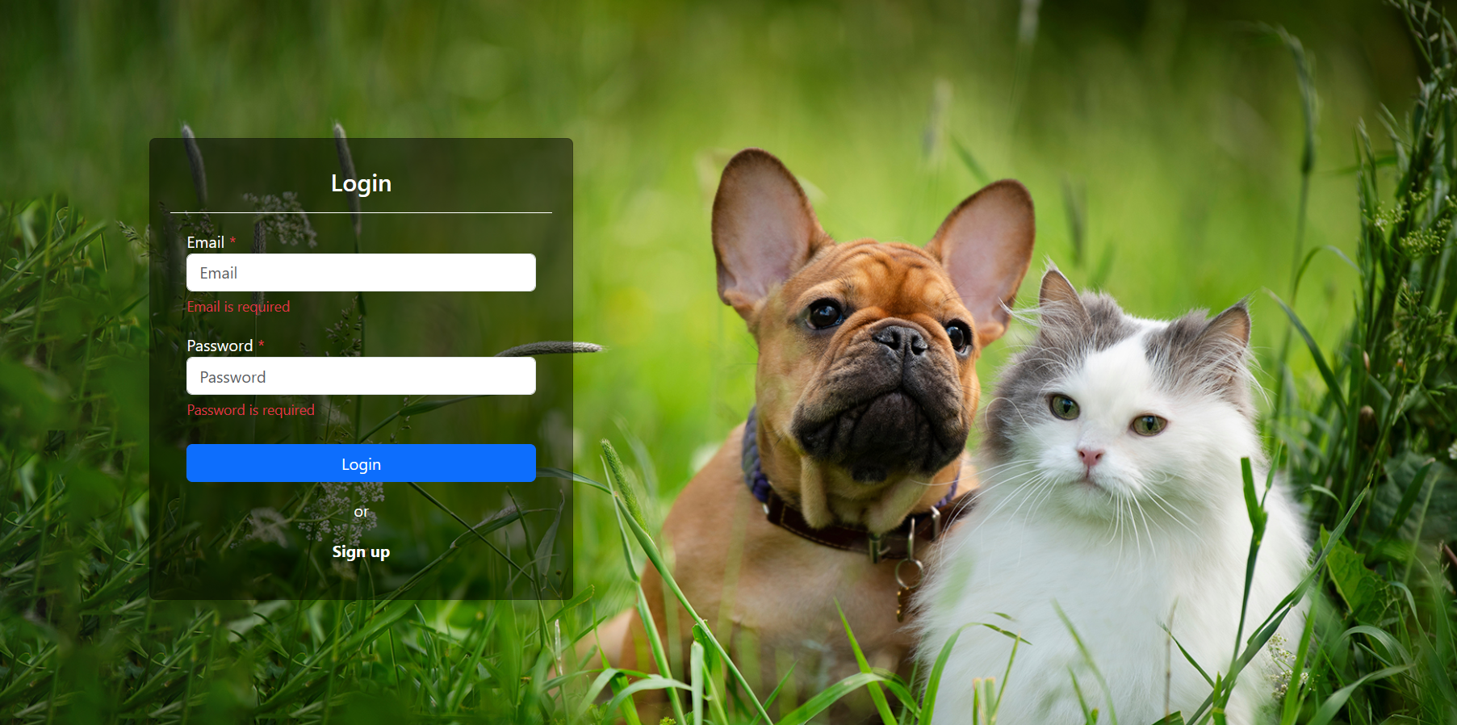

**Expected User Interface with error message using toast:**

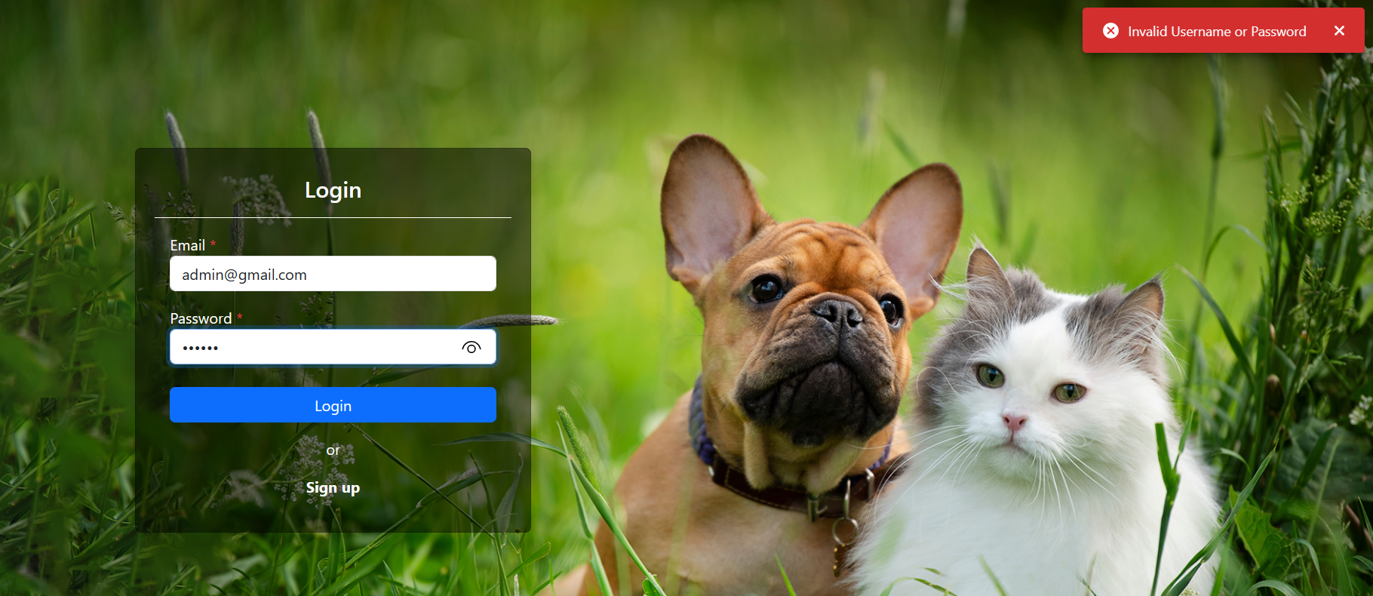

## 6.3 Creating the Dogs page:

|  |  |
| --- | --- |
| Problem Statement | The task at hand involves designing and implementing the dogs page, which requires careful consideration of both design and technical aspects. The dogs page should provide a user-friendly and intuitive experience, incorporating clear instructions. It should only be accessible to registered users.  The dogs page displays a list of dogs, including their respective prices, quantities, and a "Shop Now" button.  When designing the dogs page, please refer to the provided screen shots. Ensure that the page layout, quantity field, and "Shop Now" button is designed according to the specifications. |
| Design Consideration | Consider the following design considerations when implementing the dogs page:   * Utilize the default success color for buttons. * Each dog card should include the price, quantity field, and a "Shop Now" button. * Implement validation to display an error message in the top-right corner of the page using toast notifications when the quantity field is left unfilled. |
| Business Rules and Process | * Access to the dogs page should only be granted to registered users. * The list of dog categories is maintained in JSON format, enabling the display of dogs one by one in a horizontal manner. * Each dog category should be displayed in a row with six columns. * Maintain the active tab state for the dogs page, highlighting the dogs menu in the header as bold. |
| Skills and Features (Technical competencies validated) | * Implement the components which fits the component library standards. |
| Time Required | 2 Hours |
| Impacted components | Here is the list of components that need to be either modified or developed to meet the project requirements.  Project folder structure:   * src/pages/layout/Header.tsx * src/pages/pets/Dogs.tsx |

**Expected User Interface:**

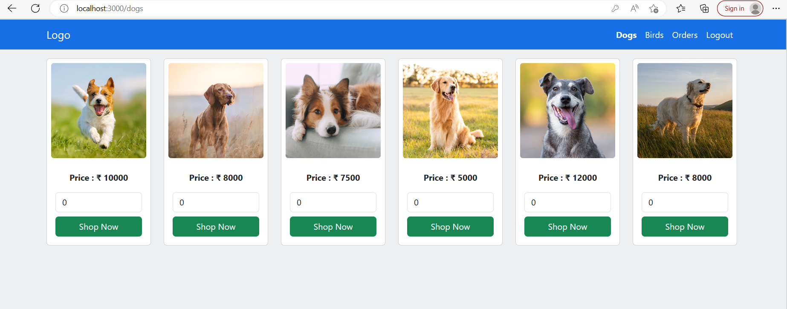

## 6.4 Creating the Birds page:

|  |  |
| --- | --- |
| Problem Statement | The task at hand involves designing and implementing the birds page, which requires careful consideration of both design and technical aspects. The birds page should provide a user-friendly and intuitive experience, incorporating clear instructions. Access to this page should be restricted to registered users.  The birds page displays a list of birds, including their respective prices, quantities, and a "Shop Now" button.  When designing the birds page, please refer to the provided screen shots. Ensure that the page layout, quantity field, and "Shop Now" button is designed according to the specifications. |
| Design Consideration | Consider the following design considerations when implementing the birds page:   * Utilize the default success color for buttons. * Each bird card should include the price, quantity field, and a "Shop Now" button. * Implement validation to display an error message in the top-right corner of the page using toast notifications when the quantity field is left unfilled. |
| Business Rules and Process | * Access to the birds page should only be granted to registered users. * The list of bird categories is maintained in JSON format, enabling the display of birds one by one in a horizontal manner. * Each bird category should be displayed in a row with six columns. * Maintain the active tab state for the birds page, highlighting the birds menu in the header as bold. |
| Skills and Features (Technical competencies validated) | * Implement the components which fits the component library standards. |
| Time Required | 1 Hour |
| Impacted components | Here is the list of components that need to be either modified or developed to meet the project requirements.  Project folder structure:   * src/Pages/Layout/Header.tsx   src/assests/pets/Birds.tsx |

**Expected User Interface:**

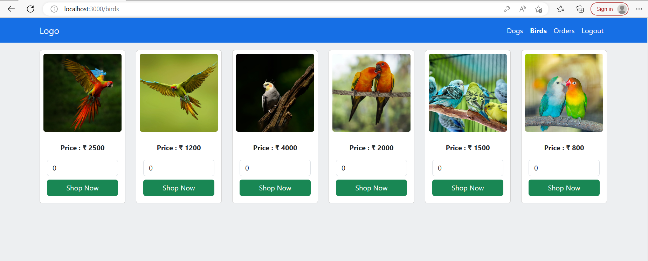

## 6.5 Creating the orders page:

|  |  |
| --- | --- |
| Problem Statement | The task at hand involves designing and implementing an Orders page, which requires careful consideration of both design and technical aspects. The Orders page should provide a user-friendly and intuitive experience, incorporating clear instructions. Access to this page should be restricted to registered users.  The Orders page displays detailed information about each order, including the pet's image, price, quantity, total price, and purchase date.  When designing the Orders page, please refer to the provided screen shots. Ensure that the page layout is designed according to the specifications. |
| Design Consideration | Consider the following design considerations when implementing the Orders page:   * Each order should be displayed as a card, with a layout of six columns per row. * Each order card should present the ordered pet's image, price, quantity, total price, and purchase date vertically. |
| Business Rules and Process | * Access to the Orders page should only be granted to registered users. * Only the purchased items of the logged-in user should be displayed on the Orders page. * Retrieve the order details by making a GET request to the following API URL:   API URL: http://localhost:3002/orders |
| Skills and Features (Technical competencies validated) | * Implement the components which fits the component library standards. |
| Time Required | 1 Hour |
| Impacted components | Here is the list of components that need to be either modified or developed to meet the project requirements.  Project folder structure:   * src/pages/layout/Header.tsx * src/pages/orders/Order.tsx |

**User Interface of Orders page:**

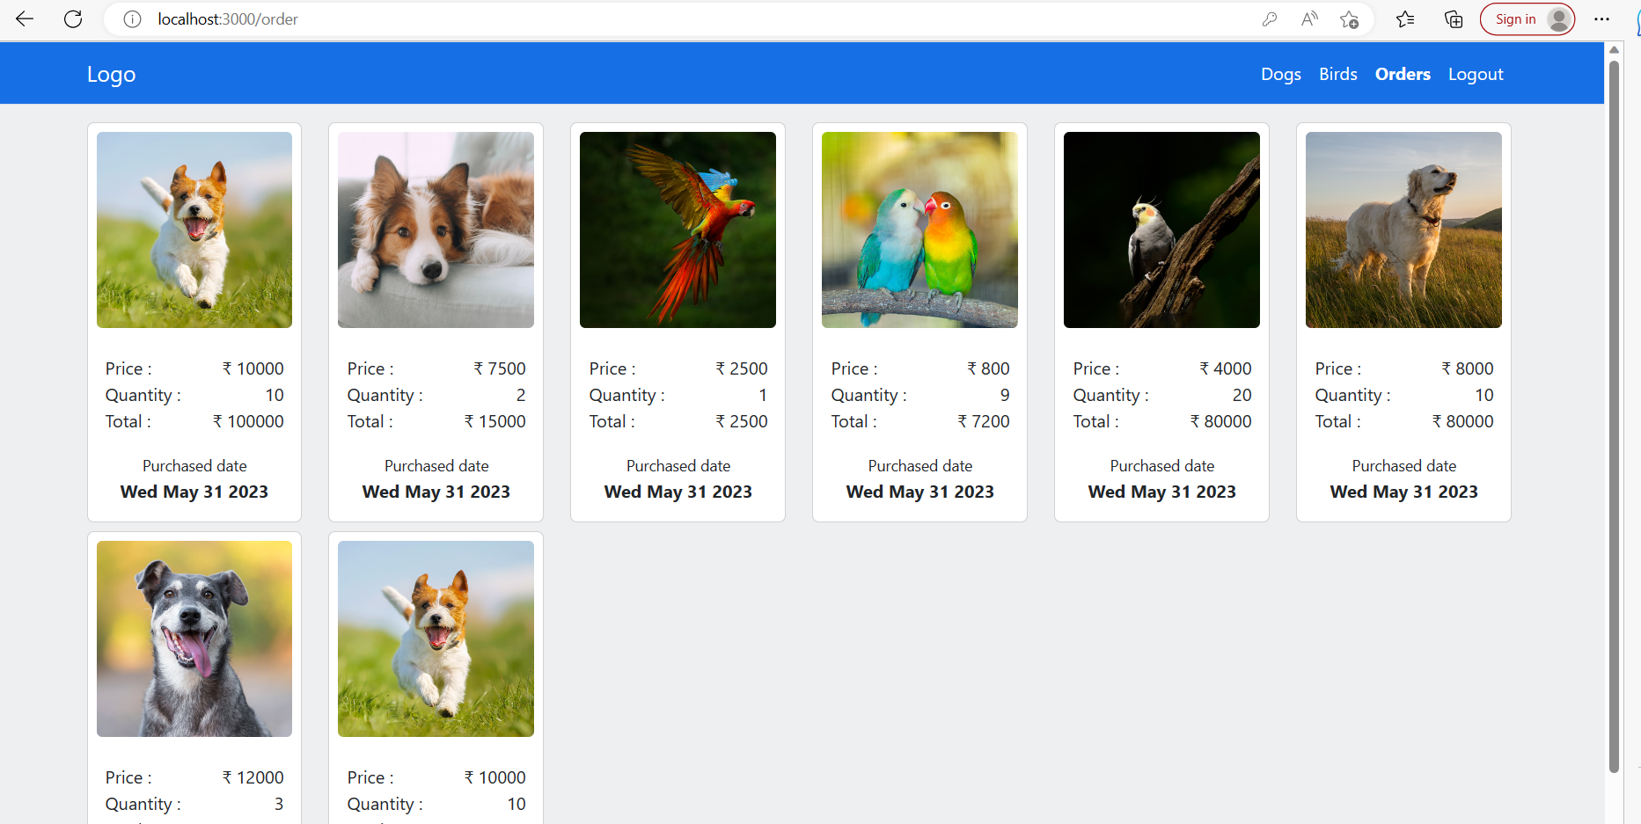

## 6.6 Create Reusable Components

|  |  |
| --- | --- |
| Problem Statement | The software requirement is to create reusable components for this React project, specifically including a button, input field, and label. As an experienced React professional, your responsibility is to design the project architecture of these reusable components, considering modularity, scalability, and maintainability. |
| Business Rules and Process | To fulfil this requirement, you need to:  Define the component structure, including the props and state.  Consider any necessary interfaces or APIs that will enhance the functionality and usability of the components.  By creating these reusable components, developers will be able to write modular, scalable, and maintainable code, reducing code duplication and improving overall development efficiency in the project. |
| Skills and Features (Technical competencies validated) | Implement the components which fits the component library standards. |
| Time Required | 1 Hour |
| Impacted components | Here is the list of components that need to be either modified or developed to meet the project requirements.  Project folder structure:   1. src/components/button/Pabutton.tsx 2. src/components/label/Label.tsx 3. src/components/inputs/input.tsx 4. src/components/image/image.tsx |

## 6.7 Implement Redux:

|  |  |
| --- | --- |
| Problem Statement | The task is to implement Redux in the project by creating a Redux store with the createStore, getState, dispatch, and subscribe methods. Additionally, a reducer function needs to be defined to handle different action types and update the state accordingly. Action types and action creators should also be created for different actions.  Furthermore, the connect Higher-Order Component (HOC) needs to be implemented to establish a connection between a React component and the Redux store. |
| Impacted components | To meet the project requirements, the following components need to be either modified or developed:   * src/pages/redux/actions/Authactions.ts * src/pages/redux/reducers/authReducer.tsx   By implementing Redux and making the necessary modifications to the impacted components, the project will benefit from state management and improved data flow throughout the application. |
| Skills and Features (Technical competencies validated) | Apply all the core and advance concepts in react and redux with all the necessary standards. |
| Time Required | 2 Hours |

## 6.8 Implement Webpack

|  |  |
| --- | --- |
| Problem Statement | The size of the application has been increasing, leading to slower loading times and performance issues. After analysis, it has been determined that the size of the JavaScript bundle being loaded by the browser is the primary cause of these problems.  As a React professional, your responsibility is to improve the application's performance by installing and configuring Webpack in the project. This involves implementing the necessary Webpack configurations to optimize the bundle size and loading process |
| Design Consideration | The following considerations should be taken into account:  Ensure that Webpack supports files with the extensions .ts, .tsx, .js, and .jsx, allowing for efficient bundling and compilation of these file types.  Configure Webpack to handle font files with extensions such as .woff, .woff2, .eot, .ttf, and .otf, enabling proper loading and optimization of font resources.  Specify that the Webpack build should support images with extensions like .jpg, .png, .gif, and .svg, optimizing the delivery and rendering of image assets.  Enable the 'MiniCssExtractPlugin' plugin, which extracts CSS code from the bundle and reduces the size of the CSS file, enhancing overall performance.  Utilize the 'Copywebpackplugin' plugin to compress assets, favicon.ico, and index.html, ensuring efficient delivery and handling of these resources.  By implementing Webpack and configuring it based on the provided considerations, you will significantly improve the application's performance, reduce bundle size, and optimize the loading of various assets. |
| Skills and Features (Technical competencies validated) | * Explain different customization options available for organizing the code (i.e., Scaffolding). * Explain the essentials of PWA / web components / Hybrid |
| Time Required | 2 Hours |

# Instructions to zip the completed code

1. Create a folder named ‘**OTJ-React-PL3 -Shopping-Pets-<associate-id>**’.
2. Go to the ‘hr-management’ folder where the completed code is available.
3. Select and copy all the files and folders in ‘shopping_pets’ folder except ‘node_modules’. Also don’t include ‘.git’ folder if it is present.

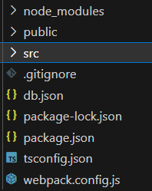

1. Paste the copied files and folders to the folder created in Step 1.
2. Zip the ‘**OTJ-React-PL3 - Shopping-Pets -<associate-id>**’ folder by right clicking on the folder and selecting ‘Send To’ > ‘Compressed Folder’.
3. The zip file name should have the folder name defined in Step 1.

======================End of the document====================